Hello Maarit, Axel (& Amitava),

Thanks again for forwarding this along. I've now had more of a chance to go through it in detail and found the results quite interesting. It's nice to see more analysis using the NL TFM – while obviously quite tricky, it can clearly be very helpful and give nice clear results.

I think these results are likely all quite consistent with ours, which is good. The kinetically forced ones look reasonably similar to those in our 2015 ApJ. If I understand correctly, you suggest that the shear-stochastic-alpha effect is the likely cause of this, using your nice analysis of the D_{AS} terms in figure 6. The conclusion seems similar to the more qualitative, visual (and TFM+CE2) analysis from our paper.
As for the magnetic runs, although we of course never tried either the NL TFM or Burger's-like MHD, the pressure force was discussed quite a bit in the JPP article as being a key component of the magnetic shear-current mechanisms (and also the well-known lack of magnetic quenching in unsheared turbulence). The diagrams in figures 2 and 3 of our JPP are a bit confusing (it all turned out to be quite complicated...), but a quite general conclusion is that the pressure-induced response is effectively the cause of the MSC effect (correlation between an initial small-scale b perturbation and the pressure response in u causes the EMF to enhance the large-scale field). Perhaps you could add something to this effect to the conclusion (or elsewhere) of your paper? I think it is probably quite an important point for these types of magnetically-induced transport coefficients. If it would be helpful, we could have a chat on zoom soon to discuss some of this?

There were just one or two other small comments I came across.

This may just be a nomenclature confusion, but I was a little confused by this comment below (25)
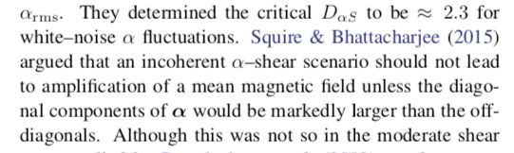
Were you referring to the discussion of the appendix in the ApJ paper? Because we certainly didn't mean to argue that the shear-stochastic-alpha dynamo (fluctuating alpha + shear) can't provide amplification (e.g., field growth figures 1 and 2 of our ApJ paper is attributed to fluctuations in alpha + shear). The appendix was specifically referring to the Kraichnan-Moffat mechanism, and various variants that have appeared in the literature. We think that this KM mechanism is unlikely to be important in general situations, but its quite different as shown by Axel & Mitra's 2012 paper.

For the discussion in this paragraph of the introduction
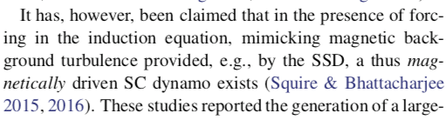
it would also be nice to mention that the analytic results (from the PRE) agreed with the reasonably strong magnetic SC contribution (unless, of course, you completely disagree with the general approach of magnetic SOCA calculations).

Anyway, thanks again for forwarding this along, and it's very nice to see more progress.

Best,
Jono

